**Report**

|  |  |
| --- | --- |
| Date | 24 September 2024 |
| Team ID | PNT2022TMIDxxxxxx |
| Project Name | Title |
| Maximum Marks | 5 Marks |

A report is a comprehensive document that provides a detailed and structured account of data analysis, findings, and insights. It is typically used for in-depth analysis, documentation, and communication of results. Reports are suitable for a diverse audience, including decision-makers, analysts, and stakeholders who need a comprehensive understanding of the data.

Designing a report in Power BI involves connecting to data sources, creating visualizations like charts and graphs, customizing their appearance and interactivity, organizing them logically on the canvas, formatting elements for consistency and clarity, and optionally creating dashboards for a summarized view. Throughout the process, it's essential to consider the audience's needs and ensure the report effectively communicates insights from the data. Finally, iterate based on feedback to continually improve the report's design and usefulness.

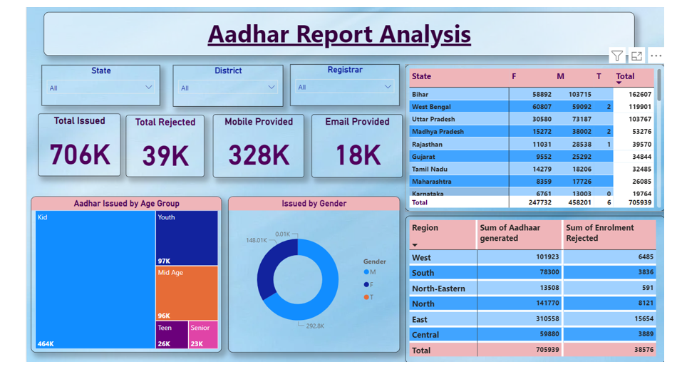

Observations drawn from reports in Power BI can provide valuable insights into business performance and trends.

**1. Trends Over Time**:

* Analyze how key metrics (e.g., sales, revenue, or customer counts) change over different time periods (monthly, quarterly, annually) to identify growth patterns or seasonality.

**2. Performance Comparisons**:

* Compare performance across different categories, such as regions, products, or departments, to determine which areas are excelling or underperforming.

**3. Customer Segmentation**:

* Assess demographic data (age, gender, location) to understand customer segments and tailor marketing strategies accordingly.

**4. Goal Achievement**:

* Measure progress against established KPIs (Key Performance Indicators) to assess whether business goals are being met.

**Example:**

1. **Gender Distribution**:

* The gender distribution chart indicates that more Aadhar cards are issued to **males (425,601)** compared to **females (247,174)**.

1. **Age Group Analysis**:

* Among the issued Aadhar cards, the **youth** category (under 18) has the highest number at **464,000**, indicating a significant focus on younger populations. This trend could suggest the need for policies aimed at youth engagement and benefits tailored for this demographic.

1. **Regional Disparities**:

* The **Central region** has the highest sum of enrollment rejections (**59,888**), indicating potential systemic issues in that area. Addressing these concerns could improve overall enrollment success rates.

1. **High Aadhar Issuance**:

* A total of **706,000 Aadhar cards** have been issued, indicating strong enrollment efforts. The states with the highest issuance (e.g., **Bihar** with **162,407** Aadhar cards) should be studied for successful outreach strategies.